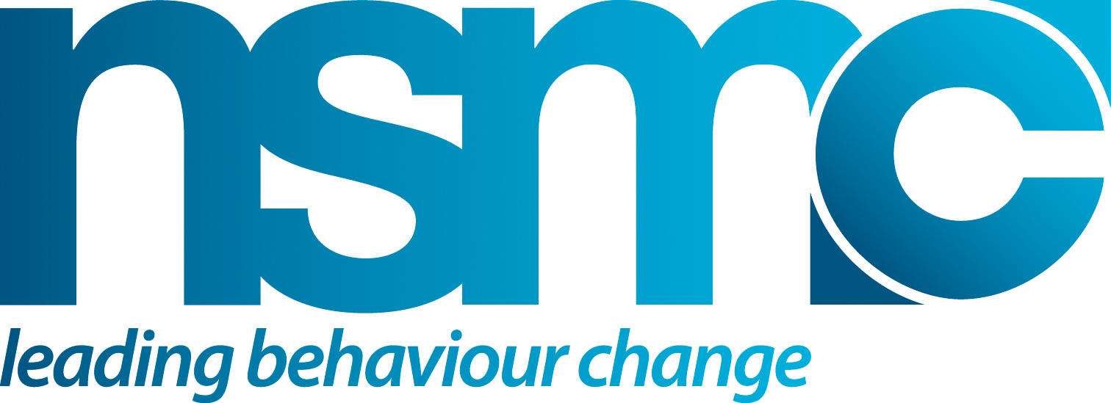

GUIDE TO SOCIAL MARKETING ON A MINIMAL BUDGET

Purpose
One of the great strengths of social marketing is that its principles and techniques can
be adopted by anyone and applied to any behavioural challenge.

Having a limited or small budget doesn’t mean you can’t develop and deliver effective intervention strategies. It does mean that you have to be very focussed and realistic about what you want to achieve. Having a social marketing, customer focussed, approach doesn’t cost anything. It is worth recognising that often it can be the approach not just a lack of funding that can limit what you can do.

What organisational constraints limit what you can do?
      - Time pressure is a common constraint. A continual need to hit annual performance
targets and use budgets by the year end can put pressure on projects to move too quickly.
- Limited funding. This can be ad hoc, arbitrarily allocated and managed annually.
- Limited staff capacity to manage, develop and deliver social marketing.
- Gaps in social marketing skills and experience, particularly in relation to discovering
and using insights from research.
- Lack of awareness/adoption of social marketing within an organisation.

What can you do?
- Adopt a social marketing approach, apply the principles from the start – putting your target customer(s) at the heart of everything you do
- Start planning as early as possible and follow a systematic process
- Do more with what you’ve got. Add to what you’ve got. Share the work
- Work the insight from the research and be creative. Your insight into your audience’s behaviour is your key asset - make sure you make maximum use of it
- Examine how your audience engages with the issue and your services, ‘the customer journey’, to make sure you can deliver maximum value with what you’ve got at all times
- Develop partnerships to assist in your, and your partners, goals and objectives
- When you have limited or low funding you need to be resourceful. You need to make the most of your assets and resources and mobilise others (people & organisations) that share an interest in your goal and are willing and able to help

How to use or apply
Use this guide to act as a checklist or prompt for maximising what you can achieve with your budget.

PLANNING CHECKLIST
Are you? | Yes/No
Clear about the behavioural challenge
Being realistic with your goals and expectations given the resources
available
Adopting an insight driven customer focus at all times
Following a systematic approach
Sharing the work - building a team
Making the most of your assets
– not least your people and your research insights
Capitalising on learning’s from others
– secondary research, other practitioner experience
Working in partnership with others

RESOURCEFUL ACTIVITIES
Asset mapping  A good place to start is to establish what resources you have at your disposal or can get access to. Asset mapping helps you identify information, services, products and community organisations that can provide help, relevant to your behavioural challenge.  Planning Guide tools  - Mapping Resources and Assets  - Resource Analysis  - Identifying and mapping stakeholders | Start by making a list of resources that immediately spring to mind (you can do this initially as an individual or together with your project team). Then build on this by asking others.  There could be many possible partners and assets (use the following heading to list possible partners and useful resources)  - local organisations,  - community groups,  - your organisation’s staff  - commercial companies,  - not-for-profit organisations
Research  Understanding your target audience(s), identifying the key insight into what moves and motivates them is essential. | The following resources are a good starting point, and are all FREE  Use electronic resources - Examples include PubMed or the Office of National Statistics website
Research continued  In most, if not all cases, there will already be secondary information available. Look at what research you have within or have referenced.  Then search for relevant external research (reports, journals, case studies, articles, data etc). Make sure you interrogate this first before you consider conducting any new or primary research. It will save you time and money.  Utilising relevant existing or secondary research will help you indentify, if primary research is needed and what it needs to cover.  Outsourcing primary research can be expensive. At this stage think about what information you need and see what you can do yourself.  Planning Guide tools  - Existing knowledge review approach  - Sources of cancer information  - Guide to NAEDI evaluation indicators  - Segmentation example variables  - Help-seeking and delay literature key insights | Existing research  Your organisation. What research exists within your organisation which may be useful to your intervention?  Use your local university. They may have local research or looking for student research or design projects.  Commercial research companies – may provide data free of charge .  Survey tools. You can design your own online survey for free using surveymonkey.com.  Other health organisations. Other PCTs/SHAs or third sector organisations may have research or experience you can learn from.  Segmentation. Has previous segmentation work been carried out that you can learn from (eg Stoke PCT segmentation and the DH Healthy Foundations segmentation).  Other free resources  General intelligence gathering:  - Google news alerts, chat rooms, blogs, Facebook, Myspace  - Trendpedia  - 43things.com  - The NSMC Showcase database  - Public Health Observatories  Cancer Information sources  - NAEDI (www.naedi.org)  - Cancer networks (all cancer networks performed a baseline assessment for awareness and early diagnosis in 2009)  - The National Cancer Equalities Initiative  - Cancer Registries  Primary research  Speak to front line staff and community leaders. They know your target audience very well and can help generate insight.  New research and audience insight. Can you attend existing meetings, groups or events to carry our new research with your target audience
Research continued | Immerse yourself. If you can’t afford research can you and/or colleagues spend time with your target audience to find out as much as you can about them
Developing and working in partnership  Social marketing is all about the ‘exchange’ to the target audience. When developing partnerships, you need to think about the ‘exchange’ for your partners. What will partners benefit from being involved in the project and how can the project help them achieve their objectives?  Planning Guide tools  - Identifying and mapping stakeholders  - Potential stakeholders list | Partnerships can be developed to provide access to:  - Members  - Sharing resources and budgets  - Websites  - Information and research  - Publications  - Key stakeholders  - Events  - Venues  Review your asset mapping to find out where you may need extra support for your intervention and identify possible partners who may be able to help.
Developing your intervention  It is important that you have a clear target audience for your intervention. Then identify any barriers and motivators your audience may have towards the behaviour objective sought. Your intervention should use these insights as a base for developing your intervention.  Planning Guide tools  - Understanding current behaviour  - Behavioural analysis  - Develop the intervention and marketing mix | Learn from others. Speak to other practitioners or people working with the same target audience.  Review existing services. Review your existing service and your target audience’s experience of the service – ‘the customer journey’. Can anything be improved?  Field testing. This can be done on a small budget with colleagues, partners, stakeholders and members of your target audience.  Use the web. The internet is a powerful intervention tool – and it is freely available to all. However, check if this channel is appropriate for your target audience. Some of the ways you can use the web include:  - Email lists – check open and click rates  - Create a face book page – and use it!  - If you are aiming at young people, maintain a presence – photos on Flickr, video on YouTube, updates on Twitter  - Use Digg and Reddit – submit your news story (there is a health category)
Starting and monitoring you intervention  Monitoring progress ensures you can react to any unintended consequences, be receptive to innovations and apply them to your programme. Ideas can come from local community resources, designers, students and firms which can often help on a project and provide time for free (These should be already listed on your assets map).  Planning Guide tools  - Process evaluation methods  - Communications development  - Pre-launch checklist | Events. Can you partner/ be involved in existing workshops and events aimed at your target audience?  Adapting existing services or products. If you do not have the budget to develop new services, products or resources are there ways you can adapt and change existing ones?  Communicating with stakeholders, staff and  partners. Develop a communication plan to  ensure stakeholders are aware of when the  intervention is starting and how it is progressing  Online marketing can be another low-cost but effective route to particular target audiences, particularly with health professionals. Well-targeted email marketing can have a real impact.  - Promote your work in an email signature  - Create your own website – many internet providers offer free hosting space and tools to create basic sites  - Set up reciprocal links to sites with similar work or interests  - Setup discussion groups, internet forums, social networking groups or newsgroups  Press releases are a good low-cost way to get media attention. Treat the media as a partner. Do you have a shared agenda? Can you help them to be a campaigning organisation? If they have a shared agenda, tailor the press releases to appeal to their agenda.
Evaluating the intervention  It is important to consider evaluation at the start of the project so the appropriate evaluation mechanisms are in place during implementation. Good evaluation can also strengthen the case for future funding.  Planning Guide tools  - Evaluation implementation plan  - Guide to NAEDI evaluation indicators | Setting a baseline. Does the existing research allow you to set a baseline with which to measure the effectiveness of your intervention.  Existing data collection. Will existing data collection provide you with enough information to evaluate the intervention? Outcome data is often routinely collected for cancer, other sources could be:  - Reviewing service-utilisation data;  - Audience and stakeholder interviews; and  - Small in-situ group discussions  Other organisations. Can you partner another organisation(s) who is already conducting research with the same target audience?
Completing the intervention  This important, often overlooked activity, allows you to say thank you, share results and maintain a relationship with your partners and key stakeholders which is important for the long-term sustainability of any intervention.  Planning Guide tools  - Follow-up commitment log  - Communications routes checklist | Intervention summary. Write and disseminate a short summary of the intervention and its results.  Thank you. Thank all those involved and share the results report with them.  Promote your results. Share your evaluation and results: promote your achievements.  Disseminating the findings. To help other similar organisations save money in the future, it is important that you share your learning and any research you have conducted. If you cannot publish in a journal, or at a conference, shared your findings on the web. Findings can also be uploaded onto websites, such as The NSMC ShowCase and NAEDI sites, as well as your own organisations website.

Source(s)/Reference(s)
- www.thensmc.com
- Social Marketing Research Resource will be available in spring 2010

