

An Initial Rapid Social Marketing Scoping Report:
Tackling obesity in Kirklees

Dr Rowena Merritt
National Social Marketing Centre

 | The National Social Marketing Centre is a strategic partnership between government and the NCC. | 

The content of this report represents an initial rapid scoping review, to assist ongoing discussion and consideration around a social marketing intervention being developed to tackle obesity in Kirklees. At this stage the view expressed are those of the author and should not necessarily be taken to represent those of the National Social Marketing Centre. Comments, views and further input are welcomed.
TABLE OF CONTENTS

Introduction
Background: the national picture
Background: the local picture
Health in Kirklees
Local Research and data relevant to tackling obesity in Kirklees
Public Health Reports
Policy drivers: The National Policy Context
Potential target audiences
Barriers to healthy living
Limited awareness of weight status
The emphasise on dieting and not healthy eating
Parental beliefs that healthy lifestyles are too challenging
Pressure on parents that undermines healthy food choices
Pressure on parents that reduces the opportunities for active lifestyles
Local stakeholder views
Interventions review
Interventions: an overview
Recommendations
References
APPENDIX I
Body mass index
APPENDIX II
Obesity and related illnesses and conditions
APPENDIX III
Proportion of adults who eat 5+ portions of fruit and vegetables per day England,
2001-2004

Introduction

The prevalence of obesity in the UK is on the rise. Kirklees has decided to take a social marketing approach to try and reduce the rise in their local area. They plan to employ a social marketing approach to address the problem. Social marketing starts by attempting to understand the consumer, in the case of unhealthy weight gain, for example, what the consumers’ attitudes to food, exercise and obesity are, and what moves and motivates them. The key questions therefore are:
- What are the problems in relation to obesity nationally and in Kirklees?
- What are the relevant national and local policy drivers?
- Who are the potential target audiences for an obesity social marketing intervention in Kirklees?
- What are the barriers to healthy living?
- What interventions to tackle obesity have been tried in the past locally, nationally and internally?
- What do local key stake holders think the problem is and what do they see to be solutions?

This report will address these key questions in an attempt to further our understanding of the issues and the consumer. At the end of this report, the National Social Marketing Centre will work closely with Kirklees to translate the findings into a social marketing intervention.

Background: the national picture

The prevalence of obesity in the UK continues to rise. Between 1993 and 2005, the proportion of men aged 16+ who were obese increased from 13% to 22%, and women from 16% to 24%. If present trends continue, 33% of men and 28% of women will be obese by 2010 (Zaninotto et al., 2005).

The prevalence of obesity in the UK continues to rise. The rate of increase in obesity among children and young people is very similar to that of adults

The rate of increase in obesity among children and young people is very similar to that of adults, rising from 9.6% to 14.9% in boys and 10.3% to 12.5% in girls up to the age of 11 years in 1995 and 2003 respectively, and predicted to be 17% and 19% respectively by 2010 (Zaninotto et al., 2005).

Box 1 Standard Definition of Obesity

Obesity is calculated through the Body Mass Index (BMI), which can be calculated by:
Weight in kilos
Height in metres = BMI
An optimum BMI is within the region of 20 to 25. Between 25 to 30 is regarded as overweight and a BMI of over 30 is regarded as obese (Appendix I).

Obesity is linked to social class, being more prevalent in routine or semi routine occupational groups, and more pronounced in women. According to Social Trends in 2001, 30% of women in routine occupations were classified in obese as compared to 16% in higher managerial and professional occupations (Social Trends 34, 2001). The long term unemployed and those that have never worked also tend to be at risk from obesity, 25% of women and 16% of men.

Obesity is linked to social class, being more prevalent in routine or semi routine occupational groups, and more pronounced in women

In 2005 the All-Party Parliamentary Group on Obesity produced a report on the links between obesity and disease (All Party Parliamentary Group, 2005). Individuals run the risk of certain diseases, the major ones linked to obesity are summarised in Box 2. Further information about the various diseases/ conditions linked to obesity is given in Appendix II.

Box 2 Obesity and disease

Diabetes Cardiovascular disease Stroke
Cancer Osteoarthritis Respiratory disease
Reproductive disorders Gallbladder disease Sleep apnea

The National Audit Office (NAO) estimated that over 30,000 deaths in England were caused by obesity in 1988, 6% of all deaths that year, 9,000 of those deaths occurring before state retirement age (Tackling obesity in England, NAO 2001). In the same year it is estimated that about 1.5% of NHS expenditure was linked to diseases related to obesity.

Indirect costs of obesity were estimated in 1998 to be £2.1 billion that is the costs of sickness, absence and premature mortality due to obesity. By 2010 it is estimated that the direct and indirect costs of obesity would rise from £2.6 billion (1998) to £3.6 billion.

By 2010 it is estimated that the direct and indirect costs of obesity will be £3.6 billion

A number of recommendations were made in the NAO report that could impact on a local level, including:
- Devising local strategies to reduce overweight and obesity
- Health authorities setting realistic milestones and targets for improving nutrition and diet and promoting physical activity
- Developing cross-departmental initiatives that can counter obesity especially in education, physical activity and diet related to schoolchildren
- Working locally with partners to increase cycling, walking and physical recreation and to improve diet, e.g. increased consumption of fruit and vegetables
- Promoting physical activity and tackling barriers to activity including poverty, cultural beliefs or fears about personal safety
- Local areas should work with the Department of Health and other partners to promote cycling and walking, and monitor progress
- Journeys to school by foot, bicycle or on public transport should be supported
- Increasing the average time spent on sport and physical activity by those aged 5-16
- School children to undertake at least two hours physical activity a week
- Ensuring health eating messages within schools, taking into account the implications of any commercial sponsorship

Background: the local picture

Kirklees Metropolitan Council covers a large area containing both urban and rural communities, situated between West Yorkshire, South Yorkshire and Greater Manchester.

There are more males than females in the younger age groups, especially the 5-9 age group. There are more females in the 20-39 age group, especially in the 25-29 age group

The population of Kirklees is 388,567 (2001 Census). The ratio of male to female is in line with England and Wales, with slightly fewer males (188,832 (48.6%)) than females (199,735 (51.4%)). There are more males in younger age groups, especially the 5-9 age group, where there are 811 more males. In higher age groups (over 70) there are 9467 more females. There are also more females in the 20-39 age group, especially in the 25-29 age group where there are 966 fewer males than females. Overall, the older population has remained reasonably static, (74,816 in 2001 compared to 74,414 in 1991).

There is a significant South Asian community in the district. Minority ethnic communities have risen from 10.7% according to the 1991 Census to 14.4% in 2001. This is above the average for England (9.1%). The main increases are in Pakistani residents (4.7% in 1991, 6.8% in 2001) and Indian (3.2% in 1991, 4.1% in 2001).

Kirklees is one of the 50 most deprived districts in England for income and employment

In many other respects the profile of Kirklees accords with national trends (see Box 3).

Box 3 Profile of Kirklees against the National Trends – similarities

- The amount of people who provide unpaid care (10.3% in Kirklees) is in line with the national average;
- Most households (70.3%) are owner occupied. 14.4% live in council rented accommodation;
- The average number of people per household has decreased from 2.54% in 1991 to 2.41% in 2001 (2.36% nationally);
- Car ownership is slightly higher than average for West Yorkshire. 70% of households have a car or van;
- The proportion of economically active residents is 66.5%. As in the rest of the country, the proportion of economically active men has decreased, and the rate for women increased;
- Part time working has increased slightly (i.e. working less than 31 hours per week), most of these workers are women, although the number of men working part time has increased from 2,900 in 1991 to 5,000 in 2001; and
- According to the 2001 Census unemployment was just above the national rate (3.8% for Great Britain) at 4.1% (6,750) of the estimated workforce.

The Census does identify some marked local characteristics of Kirklees (see Box 4).

Box 4 Profile of Kirklees against the National Trends – differences

- Manufacturing remains economically significant, with 23.8% of people in employment aged 16-74 working in manufacturing compared to 15% in England and Wales;
- One in three men, and 14% of women worked in manufacturing;
- There is less employment in service industries in the district than the national average;
- A higher proportion than the national average of people aged 16-74 had no qualifications – almost one third in Kirklees as compared to 29.1% in England and Wales;
- Only 16.9% of people aged 16-74 have Level 4 qualifications compared to 19.8% nationally; and
- 59% of people travel to work by car, nationally the figure is 55.2%.

Health in Kirklees
In Kirklees almost 17,000 people were claiming Incapacity Benefit in August 2003 (www.kirkleespartnership.org/publications/pictureofkirklees/incapacitybenefit). The increase from August 2001 of 7% was the largest in West Yorkshire (almost double the sub regional rate) and almost three times the national average. As with other indications of deprivation, Incapacity Benefit claimants are often spatially clustered, with over 1,000 people claiming Incapacity Benefit in Dewsbury West and Batley West in August 2003. South Kirklees, Golcare Home Valley North and South and Dalton had over a 13% rise in Incapacity Benefit claimants in the two years August 2001-03.

In Kirklees there has been a 7% increase in adults claiming Incapacity Benefit. This is almost double the sub regional rate and almost three times the national average

Approximately 4,000 people die in Kirklees every year. Between 1999 and 2003 there were 1,000 and over deaths per ward in Greenhead, Mirfield, Almondbury, Newsome and Liversedge and Gomersal and under 600 in Kirkburton. Wards with a high SMR include Dewsbury West, Greenhead and Batley East.

Local analysis of aggregated deaths over 5 years 1999-2003 (Locality Based Health Needs Assessment, 2003/4) identifies that:
- Deaths by cancer are below expected at 24%;
- Deaths by Ischemic heart disease are above expected at 21%; and
- Deaths by strokes are above expected at 12%.

Both of the latter are linked with obesity and raise questions about targeting social marketing initiatives in Kirklees. Deaths by these causes are spatially concentrated:
- CVD is a disproportionate cause of death in Greenhead, Batley East and Dewsbury West; and
- Ischemic heart disease is a disproportionate cause of death in Dewsbury West, North Kirklees, Batley, Liversedge and Gomersal.

Local Research and data relevant to tackling obesity in Kirklees
The LAA highlighted the lack of robust baseline evidence with which to track progress and impact of joint working and pooled funding. Mosaic data has provided higher calibre information for policy makers about the prevalence and patterns of obesity in Kirklees.

Mosaic classifies households in the United Kingdom by allocating them to one of 61 types and 11 groups, and can at greater depth be used to illustrate the major demographic and lifestyle polarities between the types and groups

When examining the Mosaic data for Kirklees by Groups it is clear that 'Families on Benefits', 'Low Horizons' and 'Upper Floor Families' are likely to have a bad diet and be likely to consume considerable amounts of beer. 'Low Horizons' are also least likely to have a good diet.

However, when looking at a percentage of the population of Kirklees, it is 'Industrial Grit' (7.18%) and 'Coronation Street' (8.72%) as types that are likely to consume the greatest amount of beer and 'South Asian Industry' (6.46%) that is most likely to have a bad diet.

Interestingly, it is apparently those in 'Semi-rural seclusion' (making up 3.39% of the Kirklees population) that are most likely to consume alcohol on a daily basis. There is no obvious explanation for this as the type does not indicate particular isolation, affluence or deprivation. Neither is there any particular reason why 'Older Right to Buy' should be one of the least likely types to enjoy a good diet as they are by no means the poorest older group. These examples may simply be illustrative of weaknesses in using Mosaic data to establish generalities.

'Industrial Grit' (7.18%) and 'Coronation Street' (8.72%) are likely to consume the greatest amount of beer and 'South Asian Industry' (6.46%) is most likely to have a bad diet in Kirklees

The map (Figure 1) indicates the geographical concentrations of those assessed to have a ‘bad diet’ by Mosaic classification. Interestingly the map indicates that it will be easier to focus resources on ‘South Asian Industry’ as the population of that ‘type’ is more concentrated in city areas. Other groups, particularly ‘New Town Materialism’ appear in small pockets across Kirklees making it harder to provide targeted services at reasonable cost.

Figure 1 Geographical concentrations of those assessed to have a ‘bad diet’ by Mosaic classification
Source: Kirklees, NHS website, 2007
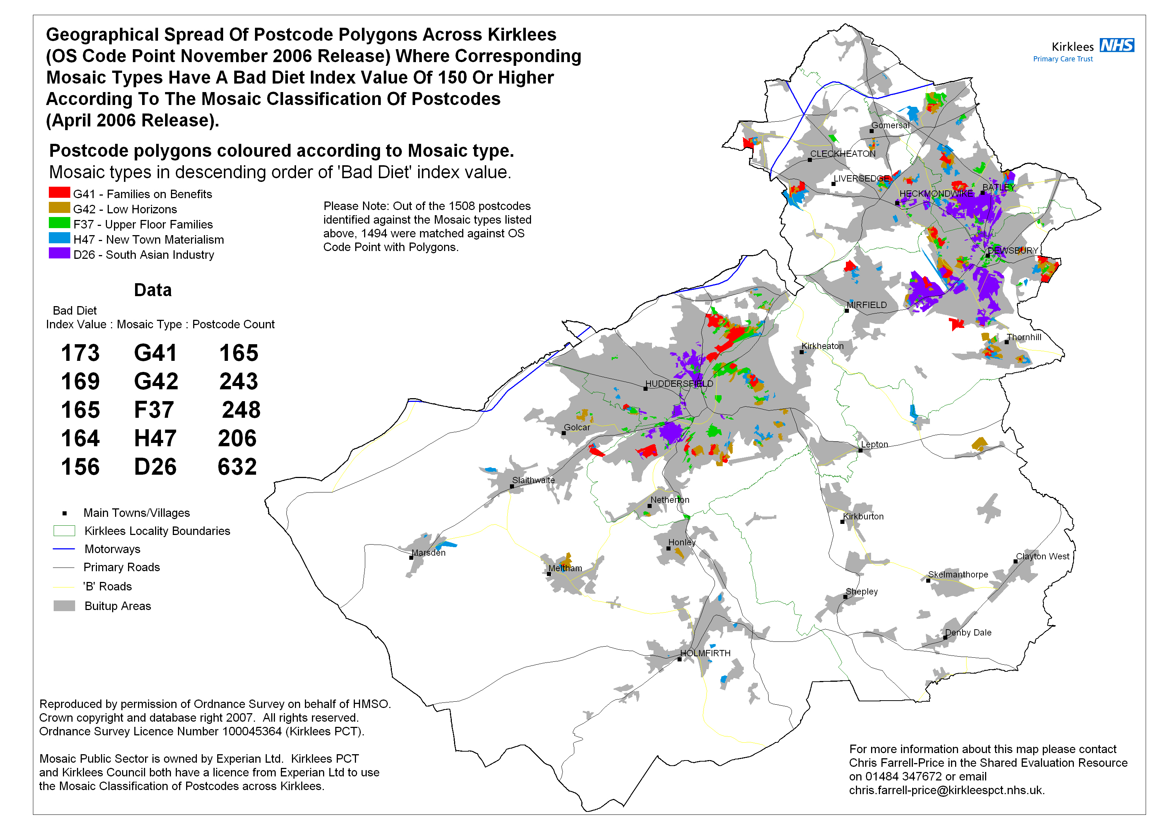
Figures 2 and 3 use Mosaic data to illustrate how likely a particular Mosaic ‘type’ is to have a good or bad diet. Those in ‘Symbols of Success’, an affluent type are least likely to have a bad diet and then most likely to have a good one. Conversely Municipal Dependency are most likely to have a bad diet and least likely to have a good one. This is logical, but amongst the other measured types there is some variation – all are not in the same position in both graphs. Without in-depth analysis of what constitutes a ‘good’ or ‘bad’ diet under Mosaic criteria however it is hard to develop any further conclusions.

Figure 2 Groups most likely to have a bad diet by Mosaic categories
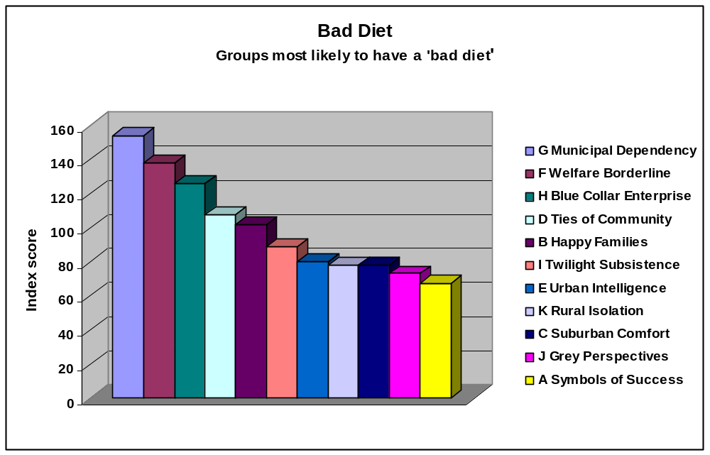
Source: Mosaic, accessed: 2007

Figure 3 Groups most likely to have a good diet by Mosaic categories
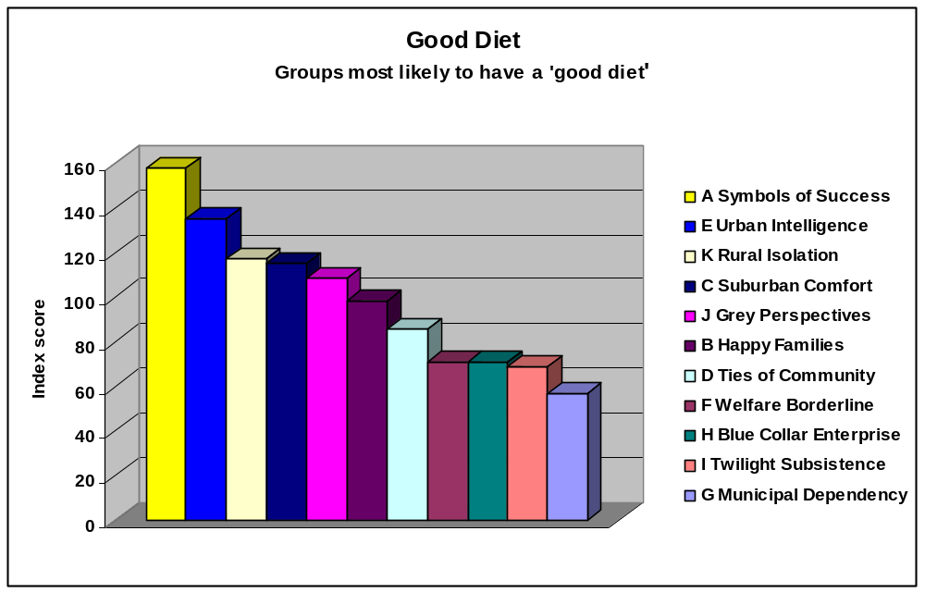
Source: Mosaic, accessed: 2007

Health Survey for England data uses the ‘5 or more’ per day rule for fruit and vegetable as an indicator of healthy eating in the Kirklees area. In South Huddersfield the proportion of adults eating 5 or more portions of fruit and vegetables per day is above the national average. In North Kirklees, the average is some 5 percentage points below that figure (see Appendix III).

In South Huddersfield that the proportion of adults eating 5 or more portions of fruit and vegetables per day is above the national average. In North Kirklees, the average is some 5 percentage points below that figure

Figure 4 shows the national obesity prevalence trend, projected to 2010. Based on the trend in obesity between 1993 and 2004 in England, prevalence is expected to increase approximately 1% point each year. Expected prevalence of obesity in the three Primary Care Trusts (PCTs) within Kirklees between 2006 and 2010, is expected to increase from 27.6% to 31.5% in North Kirklees, 25.1% to 29% in South Huddersfield and 25% to 29.8% in Central Huddersfield.

Figure 4 Proportion of adults who are obese (BMI 30+) England, 1993-2004

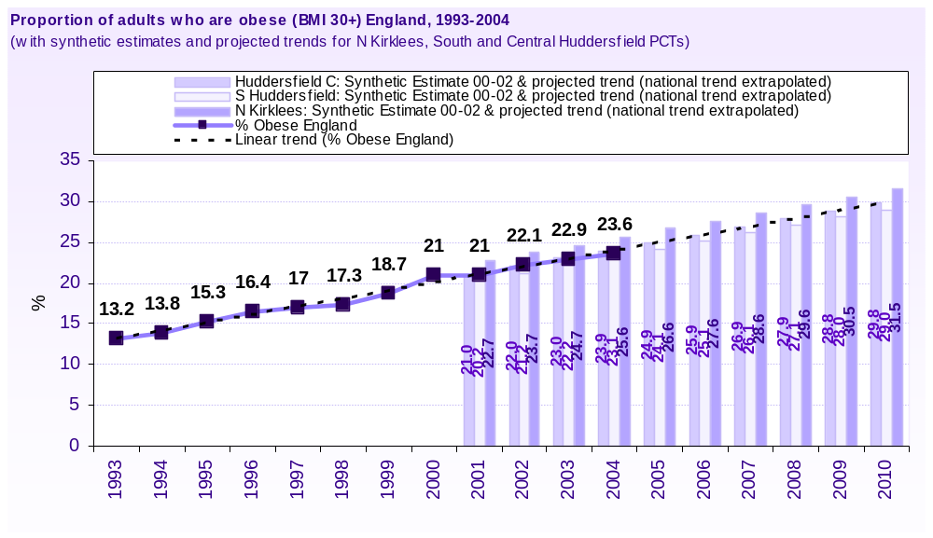

The Kirklees Tracker Survey collected self assessed height and weight data in 2006 from which local estimates of obesity prevalence have been made. The 2006 survey estimated that obesity prevalence was 18%. In comparison to the above estimates, this appears to be low.

Between 2006 and 2010 prevalence of obesity is expected to increase from 27.6% to 31.5% in North Kirklees, 25.1% to 29% in South Huddersfield and 25% to 29.8% in Central Huddersfield

Self-reported height and weight measurements are prone to error, and this may be the underlying reason for this discrepancy in addition to a response rate of just 29%. Despite this, the annual collection of such data will reflect change over time in a consistent way. Therefore, the national trend has been extrapolated onto the 2006 Tracker Survey baseline in order to project the expected trend that the survey will uncover. It is expected that obesity prevalence will increase from 18% in 2006 to 21.9% in 2010.

In Kirklees physical activity rates are below the average for England and although rising, are only doing so very slowly year on year.

In Kirklees physical activity rates are below the average for England

Public Health Reports
Kirlees PCT was created in late 2006 through the merger of Huddersfield and North Kirklees PCTs. The new organisation will serve an area coterminous with Kirklees Metropolitan Council which is envisaged will support service delivery improvements. The most recent Public Health Reports are therefore available from the two former PCTs, and were both published in 2005.

North Kirklees Public Health Report: Presenting the Picture of Health Across North Kirklees 2005
The former North Kirklees PCT covered Batley, Birstall and Birkenshaw, Dewsbury, Mirfield and Spen.

Key messages that the Report includes:
- Obesity is increasing in North Kirklees;
- Heart disease is the most significant local health issues, although death rates are falling;
- Pain problems affect 1 in 3 people, with back pain (associated with weight problems) affecting 1 in 4 people;
- Diabetes is increasing, with twice as many South Asian people suffering the condition compared to the white population;
- 1 in 8 people are very physically inactive;
- Binge drinking is a significant problem;
- Low income is related to poor health;
- People with depression often had low levels of physical activity and also smoked; and
- Young people wanted confidential information about diet more than any other subject.

As illustrated by figures drawn from the Office of National Statistics (ONS), these problems are not distributed equally in the area (Table 1).

Table 1 Obesity related health inequalities for Children and Young People in North Kirklees: 14 year olds
Health Factor  % of population | North Kirklees | Batley | Birstall &  Birkenhall | Dewsbury | Mirfield | Spen
Less than 30 minutes physical activity daily | 23 | 27 | 28 | 24 | 20 | 20
No breakfast before school | 23 | 29 | 32 | 21 | 19 | 22
Drinking weekly or more | 30 | 30 | 24 | 31 | 34 | 29
Households claiming income support with children aged under 16 | 18 | 20 | * | 23 | * | *
Families with children income deprived | 23 | * | * | 23 | * | *
School leavers not going into education or work | 9 | * | * | 10 | * | 9
Measures in bold are LAA stretch targets * no data available

In North Kirklees generally, the following key issues relevant to obesity impact on young people:
- 25% of young people never did any physical activity, especially girls
- More encouragingly, 58% of boys and 43% of girls were undertaking desirable levels of physical activity
- Football was the most popular sport for both girls and boys
- Nearly 25% had no breakfast, especially girls and South Asians
- Young people spent 15 hours per week or more on the computer or watching television

In North Kirklees, 25% of young people never did any physical activity and nearly 25% of the population as a whole skip breakfast

At a local level there were particular issues highlighted in Box 5.

Box 5 Local level issues

Batley
- Very high levels of decayed teeth evident in 5 year olds
- Particularly poor levels of physical activity
- High level of low income families
- Lowest level of household income in North Kirklees
- High level of residents living in overcrowded households
- South Asian population represents 1 in 3 residents
- Higher level of hospital admission for heart attacks than district average

Birstall and Birkenshaw
- Physical activity levels and lack of breakfast high and relatively worse than the rest of the district
- An ageing population
- A rising level of hospital admissions for heart attacks

Dewsbury
- High levels of tooth decay in 5 year olds
- High levels of child poverty
- Highest rate of Disability Living Allowance and Incapacity Benefit in the district
- Average household income below North Kirklees and the district
- The population aged 19-44 is increasing
- Worsening educational attainment

Mirfield
- Poor levels of physical activity and eating of breakfast
- An older, reasonably affluent population

Local Area Agreement
The Local Area Agreement (LAA) enshrines the legal duty a local authority has to promote the health and well being of the local population, and represents a contract between local, regional and central government to work together to deliver a range of agreed outcomes and simplify funding. The Kirklees and Local Community Strategy are both structured around four blocks:
- Children and young people;
- Healthier communities and older people;
- Safer and stronger communities; and
- Regeneration and sustainable development.

The LAA community strategy aims to help people to lead healthier lifestyles, be physically active, and have a good diet

Issues of health and well being are accorded high priority in both documents. The Community Strategy aims to:
- Close the health gap between the most disadvantaged communities and the rest of the Kirklees population;
- Help people remove the barriers to health, particularly by enabling people to have a decent home, decent income, a decent job if they are able to work, decent social networks and decent health and social care; and
- Help people to lead healthier lifestyles, be physically active, have a good diet, drink sensibly, stop smoking or reduce their exposure to tobacco smoke, not misuse drugs, manage their own health (including any health conditions they may have) more effectively.

Neighbourhood Renewal and Locality Working
In Kirklees, Neighbourhood Renewal Funding 2006-08 is targeted at the 36 most overall deprived super-out-put areas (SOA). These have been ‘clustered’ to make sense of community engagement and the drive towards delivery of key services at the seven Area Committee localities.

In Kirklees, Neighbourhood Renewal Funding 2006-08 is targeted at the 36 most overall deprived SOAs

Kirklees has eight SOAs categorised in the most deprived 3% nationally – Brackenhall, Leeds Rd corridor, Deighton/Riddings, Rawthorpe Village, Manorfield/Batley Town Centre, Fieldhead, Chickenley, Pilgrim Farm/ Becketts. In most of these cases the SOAs represent a relatively small pocket of severe deprivation (SOAs contain between 1300 to 1700 residents) in areas of already high deprivation and within communities where service improvements and existing Neighbourhood Renewal initiatives are often being addressed.

Policy drivers: The National Policy Context

The framework for utilising social marketing to help tackle obesity is firmly embedded within mainstream national policy.

The Wanless Report and the 2004 White Paper, Choosing Health are key policy drivers at the national level

The Wanless Report
The Wanless Report (2003) examined the long term resource requirements of the NHS, and concluded that better public health measures can make a positive impact on the demand for health care. Improved diet and more exercise will help reduced demands on the NHS and delay the average age when health care costs become expensive. It underlines that the costs and demands of conditions associated with obesity are largely preventable.

The Wanless Review identified three possible scenarios for meeting the future health needs of the nation:
- Solid progress: people become more engaged in relation to their health. The NHS is responsive and resources are better utilised, health improves
- Slow uptake: there is not change in the level of public engagement, and the health status of the population deteriorates or is static
- Fully engaged: levels of public engagement are good, life expectancy improves, health improves, resources are efficiently used
- To succeed in fully engaging the population, social marketing is likely to be a useful tool.

Choosing Health
The white paper ‘Choosing Health’ (2004) underlines the shift in causes of mortality from infectious diseases to chronic diseases over the last 100 years. It outlines the changes in consumer behaviour and lifestyle that have changed in that period, but also highlights that stubborn levels of deprivation still disadvantage significant sections of the population in terms of health.

People who have control over their life choices and personal circumstances are more likely to consider the day to day implications of diet and exercise on long term health. Whilst there is general agreement that information and advice can help individuals make positive health choices, consumer demand and market provision can influence these.

Deprivation can reduce access to information (either through literacy, language or basic skills barriers) availability of affordable fresh food, access to a safe place to exercise, and poor housing may equate to a lack of adequate cooking facilities.

Key messages that are relevant to obesity and social marketing that can be drawn from ‘Choosing Health’ include:
- There is a need for consistent, understandable information for consumers (e.g. a portion can mean a handful)
- Information and advice that is often quite complex should be tailored to meet the support needs of different groups
- Practical support should be provided for people who lack basic skills, including signposting to appropriate services (e.g. Skilled for Health)
- Health can be promoted in different arena (e.g. further education, workplaces)
- Regional and national media are supportive of promoting positive health
- Tackling obesity is increasingly of interest (e.g. BBC’s Fat Nation, NHS Day, ITV’s On the Move, Celebrity Fit Club)

Health Inequalities Programme for Action
In 2003, the Health Inequalities Programme for Action identified four key areas within which to achieve progress by 2010:
- Supporting families, mothers and children;
- Engaging communities and individuals;
- Preventing illness and providing effective treatment and care; and
- Addressing the underlying determinants of health.

PSA target
In July 2004 the Government has set a PSA target to halt the year-on-year rise of obesity in children aged under 11 – ‘halting the year-on-year rise in obesity among children aged under 11 by 2010 in the context of a broader strategy to tackle obesity in the population as a whole’. The Government is also committed to reducing obesity across the population as a whole. The target is owned by the Department of Health, the Department for Education and Skills (DfES) and the Department for Culture, Media and Sport (DCMS).

The PSA target is jointly held by DH, DfES and DCMS

NICE Guidelines
In December 2006 NICE issued a series of guidelines to assist stakeholders concerned about obesity implement good practice. Detailed guidance for all partners is available in “Obesity – the prevention, identification, assessment and management of overweight and obesity in adults and children” (NICE, 2006).

The quick reference Guide 1 is aimed at local authorities, schools, early years providers, workplaces and the public. This provides a number of key recommendations for local authorities and their partners, and stresses that joint strategic planning and delivery is essential. Key messages included are given in Box 6.

Box 6 Key messages recommended by NICE, by sector

For local authorities:
- Increase availability and use of safe spaces for incidental and planned physical activity
- Recognise the concerns of specific groups regarding community safety
- Provide cycling and walking routes
- Cycle parking
- Safe play areas
- Neighbourhood improvement – traffic calming, congestion charging, pedestrian crossings, lighting and walking schemes
- Design of building and spaces to encourage physical activity

Specific targets for local authorities include:
- Preventing and managing obesity in local authority workplaces
- Policy and Planning
- Encouraging active travel in the community
- Promoting and supporting physical activity
- Promoting healthy foods
- Community programmes to prevent obesity and improve diet and activity levels
- Self help community and community weight loss programmes

For Workplaces and employers:
To assist employees maintain a healthy lifestyle and manage their weight, the following actions are recommended:
- Access to healthy food in staff restaurants, vending machines etc in line with FSA guidance
- Active travel policies for staff and visitors
- Improvement to the physical environment including stairwells, provision of showers, secure cycle parking
- Recreating opportunities e.g. lunchtime walks, use of local leisure facilities

Box 6 Key messages recommended by NICE, by sector (continued)

For the NHS:
The NHS is responsible for working at both a strategic and delivery level and actions on obesity should be co-ordinated. Specific actions include::
- Provide programmes to prevent obesity, improve diet and activity levels
- Link advice on obesity to other public health actions (e.g. advice on smoking) and specific life episodes (e.g. pregnancy, menopause)
- Identify and assess overweight and obesity through BMI, waist measurement etc
- Lifestyle advice

For Self Help, community and community weight loss providers:
NICE guidance stresses the importance of statutory partners only endorsing community based providers of advice and activity to address obesity and weight loss when best practice standards are adhered to. These should include:
- Helping people decide on realistic healthy target weight (usually 5-10% of current weight)
- Aiming for a regular weekly weight loss of 0.5-1 kilo
- Linking weight loss to long term lifestyle changes
- Addressing diet and activity using a variety of approaches
- Providing practical, safe advice about being more active
- Providing advice on coping with lapses and high risk situations
- Providing recommendations to or ongoing support

The 2006 NICE guidelines offered key messages for LA, the NHS, Workplaces and community groups

Potential target audiences

The National Audit Office report discussed on page 5 identified that the risk of obesity was concentrated amongst certain at risk groups within the population:
- Children who have at least one obese parent
- Successful weight reducers who need to change their lifestyle to maintain weight loss
- People with physical or learning difficulties, especially when access to opportunities to exercise are limited
- People in lower socio-economic groups, especially women
- People in some minority ethnic communities, especially African Caribbean and Pakistani women
- Obesity in the population tends to increase with age
- A higher proportion of schoolchildren are obese

Based on the NAO Report and further research, five potential target audiences have been identified and are listed in Table 2. There are other potential audiences which the steering group for the Kirklees Social Marketing Steering Group can discuss, for example, adults and/ or children who have been told to lose weight by their GPs for specific health problems.

Table 2 Potential target audiences
Potential target audiences | Reasons why they are a potential target audience
Overweight and obese children | The Obesity PSA target is focused primarily on children under 11 years. The rate of increase in obesity among children and young people has risen from 9.6% to 14.9% in boys and 10.3% to 12.5% in girls up to the age of 11 years in 1995 and 2003 respectively, and predicted to be 17% and 19% respectively by 2010 (Zaninotto et al., 2005).
Children who have an obese parent | The NICE guidelines (2006) highlight the importance of parental engagement. The guidelines show that parental obesity is a very strong risk factor for obesity in children.
Parents with children 0-2 years and/ or Pregnant women | There is growing evidence that factors in the early years, including the in-utero period, may be important determinants of the risk of later obesity and ill-health. Lifestyle habits are resistant to change and the 0-2 year period represents an important opportunity for the infant to start on a healthy trajectory. Parents are known to be receptive to information and advice at this stage and may be willing to accept changes in their diet and activity habits for the benefit of their children than to safeguard their own health (MRC Report, 2007).
Manual workers | Obesity is linked to social class, being more prevalent in routine or semi routine occupational groups, and more pronounced in women. According to Social Trends data published in 2001, 30% of women in routine occupations were classified in obese as compared to 16% in higher managerial and professional occupations.
Long term unemployed | The long term unemployed and those that have never worked also tend to be at risk from obesity, 25% of women and 16% of men (Social Trends, 2001).

Barriers to healthy living

Evidence from diverse sources points to a number of issues that act as barriers to lifestyle change within families:
- Limited awareness of weight status;
- The emphasise on dieting and not healthy eating;
- Parental beliefs that healthy lifestyles are too challenging;
- Pressure on parents that undermines healthy food choices; and
- Pressure on parents that reduces the opportunities for active lifestyles.

These issues will be discussed in turn.

- Limited awareness of weight status
Studies have found that most people can estimate their height-weight combinations fairly accurately. However, overweight and obese people miss the mark when they’re asked to characterize the healthiness of their weight-to-height status (MRC Report, 2007).

People have a poor perception of their own weight status

In a survey conducted by the University of North Carolina only 15 percent of adults surveyed realised they were obese (Truesdale and Stevens, 2006). Such findings may offer one explanation for the escalating global obesity epidemic as people who are obese and need to lose weight may not realise it.

Parents have similar misconceptions of the weight of younger children. In a study of over 500 nursery and reception class children, only 6% of parents with overweight or obese children described their child as overweight (Carnell et al., 2005). These findings are supported by a larger survey (National Opinion Poll for Ofcom, 2004).

Research (Truesdale and Stevens, 2006) has also shown that ideals about how one’s body “should” be shaped are influenced primarily by images that are disseminated through the mass media (i.e., advertising, television, movies, magazines, etc.). For most people these ideals serve as desirable goals, but goals that are in the form of wishes:

“I really wish that my body looked like that [picture of a fashion model]...”

In the same breath that people articulate their desires for an idealised body, they also realise that these goals are not necessarily realistic:

“I really wish that my body looked like that [picture of a fashion model] but I'd have to lose 30 pounds, grow 5 inches, have breast implants, and liposuction!”
The research also found that these idealised goals are typically not associated with a plan of action because they are extremely difficult, if not impossible, to achieve. Therefore, rather than serving as direct comparisons or gauges for managing one’s weight, these ideals become a marker for fashion and entertainment.

Ideals about how one’s body “should” be shaped are influenced primarily by images in the mass media

Although people are not oblivious to weight in an absolute sense, their subjective assessments of weight are definitely not constrained by mere physical measurements. Scales, charts and tape measures - or even the way a person’s clothes fit - are employed as tools for assessing progress, not as isolated instruments for assessing weight or establishing goals.

Unhealthy diets and inactivity are risk factors for obesity but also underpin other adverse outcomes in relation to both physical health and well-being. However, there is very low awareness of these links. Moreover concerns about diet and activity may not be a priority, especially in communities with low socio-economic status. A study in the East of Scotland found that concerns about the health effects of diet were relatively unimportant compared to the risks associated with drugs, smoking, alcohol and sex (Backett-Milburn et al., 2006).

People assessments of weight are not constrained by mere physical measurements. Scales, charts, tape measures, and the way a person’s clothes fit are employed as tools for assessing weight gain and loss

- The emphasise on dieting and not healthy eating
Many people consider that healthy eating and dieting are the same. However, dieting is a distinct activity, appealing to certain types of consumers and meeting a variety of needs. Many dieters are prepared to compromise on the principles of healthy eating, at least on a short-term basis, in order to lose weight (MRC Report, 2007).

Dieting is a distinct activity appealing to certain types of consumers. Many dieters are prepared to compromise on the principles of healthy eating in order to lose weight
Research commissioned for the recent MRC Report (2007) found that healthy eaters show a different demographic profile to that of dieters. A large proportion of dieters claim to feel miserable whilst on a diet. Healthy eating would seem to be more positive; perhaps contributing towards individuals feeling good about themselves and giving rise to a sense of wellbeing.
Healthy eaters, in contrast, show a different demographic profile to that of dieters

Significantly more people understand the ‘five-a-day’ fruit and vegetables message, according to the Food Standards Agency’s 2002 Consumer Attitudes to Food survey. The survey found that more than half (52%) the people questioned had knowledge of the ‘five-a-day’ message, compared with 43% in 2000. Understanding has increased most among people in the A or B socio-economic groups (70% in 2002) and least among people in the D or E group (39% in 2002). Despite the overall increase, only 27% of respondents said they had eaten five or more portions of fruit and vegetables on the day before the survey. There was no change in the number of people claiming to regularly eat a healthy diet.

Whilst the 5-a-day message increased knowledge, it was unsuccessful in significantly changing behaviour

- Parents beliefs that healthy lifestyles are too challenging
Parents may not embrace healthy lifestyles because of beliefs, whether real or perceived, that a healthy diet and physical activity are difficult to achieve. In two-thirds of families in the UK both parents now work outside the home, compared to under a half of parents in the 1980’s (Social Trends, 2007). In a recent UK study (www.ucl.ac.uk/epidemiology/news.htm) working families were criticised. The study found that the offspring of mothers who work long hours have less access to healthy foods and physical activity. The study concluded that lack of time, and not lack of money, is the most significant factor in childhood obesity.

Lack of time, and not lack of money, is the most significant factor in childhood obesity

The findings of this UK study correlate with another European study. The study in which over 14,000 individuals across Europe participated in found that lack of time was frequently cited as a reason for not making healthier food choices (MRC Report, 2007). These trends may explain why the convenience foods market in the UK are now valued at more than £7 billion and have recorded growth well above that in food sales generally. These meals are often high in sugar and salt. (http://www.cornwallpurebusiness.co.uk/uploads/reports/the_uk_food_market.pdf).

Another barrier is linked to parent-child interactions. When faced with the prospect of resistance from their child to eat certain foods, keeping the peace at meal times became more important (Brewis and Gartin, 2006). Parents are also unlikely to introduce their children to foods that they themselves dislike (Skinner et al., 2002). This demonstrates that parents have to be targeted as well as children as it is reported that some children need to try foods seven times before they like it (researcher’s conversations with the School Foods Trust (SFT) leads, 2007).

When faced with the prospect of resistance from their child to eat certain foods, keeping the peace at meal times is more important to many parents

Many parents are concerned about the cost associated with wasted food, especially fresh fruit and vegetables. In low-income families there is no economic flexibility to experiment or throw away out of date food as low-income groups spend a much larger proportion of their gross income on food than higher income groups (Dobson et al., 1994).

Many parents are concerned about the cost associated with wasted food, especially fresh fruit and vegetables.

At the same time, cooking appears to be enjoying something of a revival in the UK, driven no doubt by the current glut of media chefs and cooking competitions on TV. Jamie Oliver has made cooking ‘cool’ and has helped raise the profile of the diet debate, especially in regard to children's eating habits. However, there is much more interest in gourmet cooking than in the provision of family meals on a daily basis.

- Pressure on parents that undermines healthy food choices
Children who are bombarded with junk food TV adverts will almost double the amount of unhealthy snacks and sweets they eat, research has revealed in April 2007 (http://www.dailymail.co.uk/pages/live/articles/news/news.html?in_article_id=450455&in_page_id=1770&ito=1490). Youngsters who are already overweight or obese are even more at risk and will increase their consumption by up to 134 per cent. The TV watchdog, Ofcom, has announced some new controls on the advertising of unhealthy foods. From the beginning of April 2007, advertisements for junk food were banned around programmes made specifically for children aged up to nine. This will be extended to programmes where children aged up to 15 make up a high proportion of the audience from January 2008. Dedicated children's channels will have to remove all advertisements for unhealthy foods by December of 2008 (www.ofcom.org.uk/).

Children who are bombarded with junk food TV adverts will almost double the amount of unhealthy snacks and sweets they eat

Food is perceived as a considerable source of family stress for nearly half of all families (MRC Report, 2007). Parental anxiety tends to centre more on inadequate, rather than excessive, food intake. In young children there are concerns over a failure to grow and develop rapidly. By school age, parents are often concerned that their children have enough energy for the multitude of activities that they have to do. The British Household Panel Survey (of 5,500 households) showed that around 40% of 6-9 year old children chose their evening meal on at least half of all occasions (MRC Report, 2007).

Peer pressure can also have a negative effect on healthy eating patterns. Children want to be accepted and belong to their peer group through their choice of food as much as their choice of clothes (Birch, 1980). A practical example of this is pack lunches. Pack lunches are frequently filled with fatty and sugary foods. A child whose pack lunch is filled with healthy foods might be ridiculed. TV advertising commissioned by food manufactures highlights this. For example, the TV advert for ‘Dairylea Lunchables’ and ‘Dairylea Dunkers’ where the child with the advertised product is regarded by his peers as ‘cool’ and they say what a ‘cool’ mother he must have bought the product.

Food is perceived as a considerable source of family stress for nearly half of all families

In older children/ teenagers, socialising and spending time with friends is prioritised over sitting down to family meals. Parents are often more concerned that their children have friends then what their children eat (Backett-Milburn et al., 2006).

- Pressure on parents that reduces the opportunities for active lifestyles
MORI undertook a comprehensive survey of numerous aspects of life in Kirklees in order to inform LAA interventions. Between March and May 2006, 3,016 self completed questionnaires were collected. Key findings relevant to tackling obesity include:
a) Use of public spaces
b) Community safety
c) Methods of travel
d) Access to services

a) Use of public spaces
37% of residents generally were fairly or very dissatisfied with the standards of cleanliness of parks and play areas in local areas, but this rises to 42% on the Pilgrim Estate and 49% in the Riddings. There is general indifference across the whole district on how parks are used for physical activities.

b) Community Safety
Not feeling safe leaving ones home is a major disincentive to physical exercise. Different groups are likely to be affected in different ways. Fear of crime appears to be an issue in Fieldhead, the Pilgrim Estate, the Riddings, Chickenley, with over 30% of the population in these areas seeing racism and hate crimes as either a fairly big or very big problem.

There was no reported significant difficulty travelling to food shops. The highest reported difficulties were on the Pilgrim Estate and the Riddings. Most people felt safe travelling to leisure and recreational facilities, but on the Pilgrim Estate, 13% felt fairly or very unsafe. Obtaining information about community safety appeared to be an issue generally, with 39% of respondents finding it fairly or very difficult to access.

Access to safe play areas for children seemed to be of general concern, with 34% of respondents on Brackenhall finding this fairly or very difficult and 54% on the Pilgrim Estate.

Fear of crime and lack of safe play areas for children was cited as a significant problem by many local residents

c) Methods of travel
Over 50% of the respondents in Kirklees generally walked to get around, with over 72% in the Riddings. Bike use is very low, a maximum of 5% by area, and 0% reported in Bradenhall.

d) Access to services
Most areas were positive about access to community facilities which are sources of advice, information, exercise classes etc. The exception was the Pilgrim Estate, where 71% of people stated access was not easy, and only 15% stated the community facility was easy to get to.

Local stakeholder views

Working with the public/ private sector
Local stakeholders in Kirklees seek to provide unbiased advice and services that will protect the health and well being of individuals and communities. They are not the only providers of advice and services related to obesity and well being. This is a market that will increase exponentially on a global scale in the next few years. There will therefore be competing sources of advice and service. Many of these will complement public health provision, but others will either potentially increase demands on budgets (for example pharmacological management of obesity) or offer only a partial solution (e.g. low carb foods).

As people become more aware of their own responsibility to try to maintain a healthy lifestyle, the health and well being market is growing and becoming more complex. Small and large players in this field that whilst seeking to make a profit are prepared to work to recognised good practice and work in partnership with the statutory sector might be useful links or partners to work with at a local level. Examples include major supermarkets, local health clubs, private hospitals and clinics, alternative therapists and specialist food retailers and organisations such as Weight Watchers.

The health and well being market is growing rapidly

A local awareness of less scrupulous practitioners should be maintained through working in partnership with Trading Standards Officers and through promoting best practice to both individuals and firms.

Given the breadth of information and services available, it must be a priority for public health practitioners to keep reinforcing that whilst there are many different approaches to weight management and fitness, they should adhere to NICE guidelines. It is evident from the amount of internet based advertising for obesity tackling products that unlicensed drugs are easily available to purchase. It is encouraging to note though that Hitwise, a leading on line competitor information service (www.hitwise.co.uk) notes that people are looking less for fad diets and more for scientifically balanced approaches to dieting and fitness on the internet.

Global and niche markets are likely to occur in the following areas, all relevant to tackling obesity, and some that certain individuals will feel offer a solution to their obesity:

- Private gyms and personal trainers
- On line personal trainers
- On line nutrition planners
- Slimming clubs
- Private hospitals offering pharmaceutical and surgical therapies
- Alternative therapists
- Equipment for personal monitoring, e.g. heart rate monitors, body fat scales
- Slimming pills
- Appetite controllers and suppressants
- Low carb products
- Diets
- Low fat snacks and drinks
- Low fat ready meals
- Meal replacements

Local stakeholder interviews
In addition to collecting and analyzing local data, key stakeholders within Kirklees were consulted about their views on the priorities that any social marketing initiative should tackle. A list of those consulted is listed below. Consultation took place in June and July 2007 by phone and email.

Key results from Local Stakeholder consultation:

Question posed: Who are the obese?

Responses:
- Obesity is a growing problem in all sectors of the population, with nearly 1 in 5 adults currently obese.
- 7 out of 10 Kirklees adults are not active enough to benefit their health
- Over 50% of over 65s are sedentary
- More people on low incomes are sedentary
- More South Asian people in Kirklees are sedentary than any other population group
- Rates are worse amongst women
- Men aged over 25 are a group that is causing increasing concern

Question posed: Why are they obese?

Obesity in Kirklees is caused by:
- Low levels of physical activity
- Inappropriate eating behaviours
- Lack of knowledge of healthy eating/physical activity
- Poor emotional well being
- Inability to recognize overweight and obesity in themselves and their children
- Children of overweight and obese parents
- People who are overweight and gaining weight
- Adult life stages, e.g. smoking cessation, young men in their 20s and 30s, menopause, pregnancy
- Sedentary adults e.g. TV viewing, take aways, alcohol
- People who consume more sweets and drinks high in sugar
- Lifestyle factors (knowledge/behaviour/skills) - more calorie intake than expended. Diet high in fat sugar salt, low intake of fruit/veg. Larger amounts of foods (portion control). Drinking over rec. levels of alcohol- binge drinking.
- Barriers to healthy eating/ physical activity – income/cost, accessing services/facilities, personal motivation, confidence/cooking skills.
- Genetic factors – obese parent(s)
- Family influence e.g. food in home, family dining
- Social norms /peer attitudes – takeout food
- Media /advertising

Stakeholders identified obesity is a growing problem in all sectors of the population, but in particular amongst women, the over 65s, and those families on low incomes

Question posed: How should we tackle these issues?

- One to one support (health/weight management
- Group/peer support
- Knowledge/awareness/information/understanding
- Ability to recognize overweight and obesity in themselves and families
- Provision of appropriate interventions
- Making the healthy choice easier
- Environmental changes to help people become more active
- Families/parents – family based programmes to support overweight parents/children re; lifestyle changes/weight loss and influence norms/attitudes of young children
- Young men- overweight rates increase from age 25. Focus on fitness/body shape/attractiveness rather than health messages
- How to access men in range of locations – pubs, community groups, sport associations etc.

Low levels of physical activities, lifestyle factors, inability to recognize overweight and obesity in themselves and their children, and inappropriate eating behaviours were the most identified reasons for causing obesity in Kirklees

Question posed: What activity is already underway?

- Opportunistic advice given when attending other appointments
- Brief interventions in primary care
- Weight management clinics
- Counterweight (9 practices)
- PALS – exercise referral – all practices signed up
- Get Foodwise and Exercise programmes
- MEND
- Health trainers
- Community based weight management – e.g. Slimming World, Weight Watchers
- Range of Community based physical activity programmes
- Food info/cook and eat sessions
- Range of promotional materials regarding food and physical activity

A long list of activities which are currently under way in Kirklees to tackle obesity were given, including PALS, MEND, Get Foodwise and Exercise programmes, to name just a few

Question posed: What is the profile of existing participants?

- Approximately 23% of those referred to PALS have a BMI of 25+ (60% women)

Question posed: What should we do more of?

- PALS can only take 2000 patients a year – this is not enough
- Targeting women of childbearing age, especially those that smoke, have poor levels of physical activity, misuse alcohol etc, as they are key influencers of family health behaviours – this target group will help social marketing as there are so many community links to be made
- Innovative provision needs further developing and delivering

With thanks to the respondents:
Alison Morby, Physical Activity Development Manager, Kirklees Council
Joe Baker, Sport and Development Officer, West Yorkshire Sport
Phil Longworth, Health Policy Officer, Kirklees Council
Julie Tolhurst, Public Health Associate Specialist and Food Lead, Kirklees PCT

When asked what we should do more of, the stakeholders advised that more patients should be enrolled into the PALS programme and that women of childbearing age should be targeted with an intervention

Interventions review

In this section, various interventions will be reviewed which have had, or are intended to have, an impact on obesity and the promotion of healthy eating, in particular among children and young people. These include local, national and international initiatives, and represent a mixture of top down and bottom up interventions. Where possible, the observed impact of these interventions is supported by statistical information. In some instances, interventions are still at an early stage, and evidence of success or failure is yet to be collated.

Full details of the interventions are given in a separate document titled ‘Behavioural interventions for healthy living: International, national and local examples’. For the purpose of this report, an overview of the interventions has been included. A summary of the interventions are given in Table 4.

Interventions: an overview
It is evident that a host of interventions are currently being implemented around obesity in the form of physical exercise interventions and ones which encourage sustainable healthy eating habits, in particular amongst school children. The interventions ranged from parental education incentives, cookery lessons, group exercise classes, group exercise classes, cardiac rehabilitation activities - the list goes on. The funding sources were multiple and many interventions combined national, and LA funding with PCT money. Partnerships with large supermarkets were used in two of the interventions.

What also emerged from the interventions review, however, is that there is a current profusion of information initiatives, support services, regulations, guidelines, websites, marketing campaigns, case studies, debates, conferences, awards and incentive schemes, all of which aim to reduce obesity and promote healthy eating. While this wealth of interventions reflects the weight that is being given to the problem of obesity and marks a positive climate for change, there is a potential for confusion, overabundance, and fragmentation within the sector, and a need to be alert to proliferation and duplication as a potential barrier to clear communication of messages, behaviour goals and targets.

Table 4 Summary of behavioural interventions
Intervention title | Intervention objectives | Intervention | Results
International

Neighborhood shops initiative – Scotland | To successfully and profitably promote the healthy living brand and healthier food choices | - Healthy meal deals  - Fruit coupons  - Free fruit for every child accompanying a parent on a shopping trip  - A free piece of fruit with non-sugar drinks  - Placing fruit by checkouts | - A 14.6 % increase in total soft drink sales  - A promotion featuring a healthy range of ready to eat meals resulted in a 260 % increase in sales;  - Moving fruit and vegetables from the rear of a store to the front resulted in a 36 % sales increase in the first week and has produced ongoing increases of 2 %
Food Dudes – Ireland | Increase the intake of fruit and vegetables in school children | - Stickers  - Certificates  - Food Dude prizes  These are given to children who eat fruit and vegetables as incentives to follow the Food Dudes' healthy eating advice. | - Consumption of all types of fruit and vegetables increased following introduction of the programme.  - The increases were particularly large for foods that were unpopular at first, like prunes, pears, peas and green beans.
Table 4 Summary of behavioural interventions (continued)
Intervention title | Intervention objectives | Intervention | Results
Verb – USA | Increase tween participation in physical activity | Materials were developed for parents, health professionals and teachers, with separate materials developed for tweens. | - 74% of children surveyed were aware of the VERB campaign.  - Levels of self-reported sessions of free-time physical activity increased for important subgroups of children 9 to 13 years of age.
National

The Food Standards Agency (FSA) | Increase the intake of nutritional foods | - Cooking bus  - Cooking lessons | - Over three years the state-of-the-art mobile kitchen will involve more than 18,000 pupils and 2,400 teachers in its interactive cooking sessions, plus those taking part in projects during the school holidays.
5-A-Day Programme | increase consumption of fruit and vegetables amongst children | - School Fruit and Vegetable Scheme  - Lottery-funded local initiatives in 66 PCTs  - A communications programme including a 5-A-DAY logo | - School staff regarded the Scheme as: a way of improving children's health (99%) and a supplement to children's diets (99%)  - 97% of schools regarded the Scheme as a support to teaching and learning about healthy eating  - More than half of the survey schools (55%) had noticed an improvement in the ethos and atmosphere in their school
Table 4 Summary of behavioural interventions (continued)

Intervention title | Intervention objectives | Intervention | Results
National Healthy Schools Programme | Increase healthy eating and physical activity in school pupils | - Free drinking water  - Lessons on healthy eating and the need for physical exercise  - Healthier school meals | - 63% say that the Programme is making a contribution to pupils having healthier lifestyles  - 23% say that the Programme is making a contribution to raising pupil achievement  - 21% say that the Programme is making a contribution to reducing health inequalities  - 27% say that the Programme is having a positive impact on social inclusion
Local

The People’s Movement – Sheffield | To encourage and support people to be more physically active and to promote 30 minutes exercise on as many days as possible, broken down into bite size chunks of 10 minutes | - A young people's physical activity campaign promoted through competitions  - A website with information and personalised activity diary  - Events such as walking festivals, belly dancing and salsa nights  - dvds  - Informational Leaflets and posters  - Promoting local parks and leisure facilities. | Awaiting evaluation
Table 4 Summary of behavioural interventions (continued)

Intervention title | Intervention objectives | Intervention | Results
Eatsome Cooking Skills Projects - Cornwall | To promote healthy eating through practical and realistic sessions | - After school clubs  - Cookery lessons  - Information leaflets | - 41% increase in the ability of participants to cook.  - 31% of participants (increased from 18%) reported to be eating five portions of fruit and vegetables a day.
Promotion of the physical activity message for children and young people - Great Yarmouth and Weymouth | Increase in number of children undertaking 60 minutes of physical activity a day and maintain those already exercising for that amount of time | - Swivel dog clip to attach locker keys  - Assembly with sporting champion | Awaiting evaluation
Local Exercise Action Pilot (LEAP) - Great Yarmouth | Increase the number of adults exercising for 30 minutes, five times a week. | - A total of 400 activities are now on offer as part of the programme.  - Different interventions were developed for different target audiences, for example, for GPs a database of all the activities that can be done in the local area was developed. | - 35% decrease in the number of participants classified as sedentary after interventions, compared to previously.  - 67% reported improved vitality and improvements on other physical and mental health measures.
Changing the snacking behaviour of under 4’s in deprived areas - Cheshire and Merseyside | To increase the proportion of children between the ages of 2-4 years from lower socio-economic groups in the ‘ChaMPs’ area reporting eating at least one fruit or vegetable snack more than prior to the campaign | - The retail partner (Aldi) was used to deliver key aspects of the campaign.  - They developed in-store messages, concerning the value of fruit and vegetables as a snack for children aged 2 – 4 years.  - They also delivered gifts of fruit and vegetables to Sure Start nurseries | Awaiting evaluation
Table 4 Summary of behavioural interventions (continued)

Intervention title | Intervention objectives | Intervention | Results
Childhood Obesity Campaign - Brighton and Hove | To increase the number of children taking physical activity and eating healthily in Brighton and Hove | - Workshops  - Community events  - Fun days  - Information booklet  - Website | - The campaign was successful in directly communicating motivating healthy living messages to over 5000 children across Brighton & Hove.  - ‘Hundreds of parents and siblings’ attended the taste tests at the end of the day, with over 100 guests at some schools.
Activmobs scheme - Kent | To increase physical activity levels of the Park Wood estate residents | Three ‘mobs’ were created by residents:  1) Welliemob – a five-strong team of dog walkers  2) Backmob – an older group who took up gentle exercising under the supervision of the trainer  3) Timemob – which would conduct walking tours of local historical sites of interest | Unclear

Future interventions
The Departments attached to the PSA target plan to tackle child obesity through a range of approaches aimed at both prevention and treatment: for example, encouraging and supporting healthy eating and physical activity, particularly in schools; targeting antenatal nutrition; media campaigns; and treating those children who have become overweight or obese.
Recommend next steps in the development of a social marketing intervention

The following recommendations will be discussed in full and acted upon during the meeting with the Kirklees Social Marketing Steering Group and the NSM Centre.

Actions:

1) Decide upon the target audience. Several target audiences have been identified in this report. The Kirklees Social Marketing Steering Group must discuss and decide upon which target audience to focus their finite resources upon.

2) Set up a solution group. Consider having individuals from inside and outside your organisation on your strategy team. Include colleagues who work on your health problem and individuals who have these essential technical skills:
- Surveillance
- Marketing research and analysis
- Expertise in interventions and best practices related to the problem
- Programme development
- Social marketing and health communication
- Evaluation

External partners with a vested interest in addressing the problem and the authority to represent their respective organisations can add new points of view, resources and experience. Engaging external partners early in programme planning helps create allies rather than competitors. Consider external partners like:
- Government agencies
- Local health departments
- Voluntary health organisations
- Hospitals/other healthcare systems
- Professional organizations
- Schools, colleges and universities
- Local government commissions/advisory groups related to the target audience and health problem
- Advocacy groups representing the target audience
- Community-based organisations
- Private foundations/business organisations that can provide funding/access to the target audience
- Businesses with a financial interest in your health outcome/topically related product (e.g. running shoes for a physical activity campaign)

3) Qualitative research with the chosen target audience. This report discusses the drivers and barriers to healthy living. The Kirklees Social Marketing Steering Group should discuss these drivers and barriers in relation to their local target audience. Qualitative research can be used at the local level to test whether the drivers and barriers identified in national research are applicable to the chosen target audience. The research will also be used to segment the target audience by current behaviour and psychographics.

4) Current service provision. Current services available in the Kirklees area should be identified and discussed. As part of identifying the current services provided in the local area, a competition analysis can be conducted by the Social Marketing Steering Group.

References

All Party Parliamentary Group on Obesity: Report on Obesity and Disease, December 2005

Backett-Milburn KC, Wills WJ, Gregory S, Lawton J. Making sense of eating, weight and risk in the early teenage years: Views and concerns of parents in poorer socio-economic circumstances. Social Science and Medicine 63(3): 624-35, 2006

Brewis A, Gartin M. Biocultural Construction of obesogenic ecologies of
Carnell S, Edwards C, Croker H et al., Parental perceptions of overweight in 3-5y olds. International Journal of Obesity 29(4): 353-5, 2005

Childhood: Parent-Feeding versus child-eating strategies. American Journal of Human Biology. 18:203-13, 2006

Department of Health, Tackling health inequalities: Status report on the Programme for Action, August 2005

Department of Health. Choosing health: Making healthy choices easier. London: Department of Health, 2004

Dobson B, Beardsworth A, Keil T, Walker R. Diet, Choice and Poverty: social, cultural and nutritional aspects of food consumption among low-income families. Oxford: Family Policy Studies Centre, 1994

James WPT. Socio-economic determinants of health: the contribution of nutrition to inequalities in health. British Medical Journal 314:1545-1549, 1997

Kirklees Local Government. Accessed: August 2007. Available at: www.kirklees.gov.uk/community/statistics/deprivation/supoutput-area.shtml

Kirklees Local Government. Accessed: August 2007. Available at: www.kirkleespartnership.org/publications/pictureofkirklees/incapacitybenefit

Kirklees Local Government. Accessed: August 2007. Available at: www.kirkleespartnership.org/publications/pictureofkirklees/infantmortality

Kirklees Partnership, Community Safety Strategy, 2006-08, Census 2001
MRC Report. The ‘Healthy Living’ Social Marketing Initiative: A review of the evidence, 2007

National Audit Office. Tackling obesity in England: report by the Comptroller and Auditor General. London: Stationery Office, 2001. Accessed August 2007. Available at: www.nao.gov.uk/publications/nao_reports/00-01/0001220es.pdf

NICE, Obesity: the prevention, identification, assessment and management of overweight and obesity in adults and children, December 2006.

Ofcom. Accessed: August 2007. Available at: www.ofcom.com

Skinner JD, Carruth BR, Bounds W, Ziegler P, Reidy K. Do food related experiences in the first two years of life predict variety in school-aged children? Journal of the American Dietetic Assocation 102:1638-47, 2002

Truesdale, K.P., and J. Stevens. 2006. Do the obese know they are obese? Experimental Biology 2006. FASEB Journal 20, March.

UCL. Accessed: August 2007. Available at: www.ucl.ac.uk/epidemiology/news.htm

Wanless D. Securing our future health: taking a long-term view. Final report. London: HM Treasury, 2002.

Zaninotto P, Wardle H, Stamatakis E et al., Forecasting Obesity to 2010: Report to the Department of Health, 2005

APPENDIX I Body Mass Index

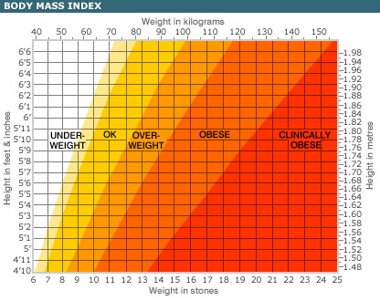
Source: www.BBC/health/healthyliving/bmi

APPENDIX II

Obesity and related illnesses and conditions

Obesity and stroke
In England and Wales 130,000 people have a stroke each year. The impact on society and individuals is severe:

“Stroke is the third biggest killer behind cancer and coronary heart disease and the greatest cause of disability in the UK” (All Party Parliamentary Group, 2005).

Obesity is indirectly linked with strokes, as obese people are at higher risk from high blood pressure, high cholesterol and abdominal fat.

Obesity and cancer
Recent research implies there is a link between obesity and cancer mortality. There is evidence that obesity increases risk for some cancers, and poor diet, smoking and excessive alcohol consumption increase risk. One cancer prevention study concluded that the relative risk of death from uterine cancer was 6.25 times higher in obese women than women of healthy weight. There is also a positive relationship with cervical and breast cancers, and some evidence for a link between deaths from bone marrow disorders.

It would appear obese post menopausal women are particularly at risk, although contributory factors might be that obese people cannot cope so well with cancer treatments. There are clear benefits in weight reduction and cancer prevention. Women losing more than 9kg in weight reduced by 35% their cancer mortality risk.

Obesity and Heart Disease
This report highlights the potential human and financial costs of Metabolic Syndrome, which result in Cardiovascular Disease (CVD), the greatest public health threat in the UK for the foreseeable future. Key facts about Metabolic Syndrome include:
- prevalence rises with age
- positive relationship with obesity
- approximately 20% of the UK population have Metabolic Syndrome
- Links with several other diseases

The most important indicator for this condition is not simply weight, but the amount of body fat and its location. BMI is not a sufficient measure. A waist circumference of more than 94 cm in men or 88cm for women indicates a risk. For some ethnic populations, this figure is lower.

The greatest risk factor for heart disease is raised blood cholesterol, a factor in almost half of the deaths nationally from Coronary Heart Disease (CHD). This is a risk factor that can be effectively tackled through diet and lifestyle and have a profound impact on reducing deaths, and the report states:

“Cholesterol, therefore, plays an integral role in related diseases/conditions and should be a specific area of focus for public health initiatives, if the government is to successfully improve the health of the nation”.

Obesity and Diabetes
Excess weight diminishes the body’s response to the action of insulin (insulin resistance). Excess production of insulin results in failure to control the level of glucose in the blood, i.e. diabetes. Of greatest public policy concern is the rise in childhood diabetes.

The Early Bird Study (2000-2012) is tracking 300 children who were healthy at the outset of the study. Early findings have revealed:
- Girls as young as five years old appear at much greater risk of insulin resistance than boys;
- The level of body fat is rising much faster in both sexes than was apparent in the previous decade; and
- Many parents are not able to accurately assess their weight or that of their children. Of overweight children, 60% of fathers and 35% of mothers thought their children were a normal weight.

Obesity and Genetic Factors
Poor diet and insufficient exercise are two factors contributing to obesity. There is an increased understanding of genetic factors, it is estimated that up to 70% of the variation in BMI between individuals could be due to genetic causes. Given the increased stigma of obesity that might accompany public health campaigns on obesity, this potential cause must be clearly communicated to professionals, parents and the media.

Obesity and Psychological and Social Issues
Factors not considered by the All Party Parliamentary Group included the social costs of obesity. In the NAO report (11, p55) research is quoted that found that obese children were consistently rated the least attractive by their peers. Obesity was rated a social stigma by 78% of girls of healthy weight. Obese children were stigmatised by their peers for both perceived physical and character reasons (i.e. the perceived failure to control weight).

Obesity and Mental Health
The complex relationship between obesity and psychological well being is hard to analyse (NAO report, 11, p 56). It is clear that extremely obese patients who undergo surgery to induce weight loss cited social rather than medical reasons as a motivating factor, with 77% considering themselves unattractive and depressed.
APPENDIX III

Proportion of adults who eat 5+ portions of fruit and vegetables per day
England, 2001-2004



